
INTERNSHIP PROJECT REPORT
Machine Learning
Session: 2025 - 2026
Company: Unified Mentor Pvt. Ltd.
Duration: 45 Days
College: Jodhpur Institute of Engineering and Technology
Submitted By: Lakshdeep Singh
Submitted To: Unified Mentor
Project Title: IoT-Based Edge-AI Real-Time Fault Detection and Predictive Maintenance System for Industrial Assets
Table of Contents
- Acknowledgement
- Abstract
- Introduction
3.1 Internship Overview at Unified Mentor Pvt. Ltd.
3.2 Primary Objectives
3.3 Project Scope
- Company Profile
4.1 Background and History
4.2 Mission and Vision
4.3 Products and Services
4.4 Organizational Structure
- Project Description
5.1 Problem Statement
5.2 Objectives
5.3 Methodology
5.4 Tools and Technologies Used
- Work Performed
6.1 Step-by-Step Implementation
6.2 Diagrams and Workflow
- Challenges Faced and Solutions
- Result and Analysis
8.1 Model Performance Metrics
8.2 Feature Importance Analysis
- Learning Outcomes
- Conclusion
- References
11.1 Books
11.2 Online Resources
11.3 Software Tools
- Appendix
12.1 Performance Comparison Table
12.2 Project Screenshots and Code Snippets

Acknowledgement

I would like to express my sincere and heartfelt gratitude to my company mentor for their continuous guidance, valuable suggestions, and unwavering support throughout the course of this project. Their deep knowledge, practical insights, and willingness to share their expertise played a crucial role in helping me understand real-world applications of the concepts involved. Their encouragement and timely feedback not only enhanced my technical understanding but also motivated me to approach challenges with confidence and determination, ultimately contributing to the successful completion of this project.
I am equally grateful to my faculty guide for their constant supervision, constructive feedback, and academic support. Their guidance has been instrumental in shaping the direction of this project and ensuring that the work meets academic standards. Their patience, encouragement, and valuable suggestions at every stage helped me stay focused, improve my analytical thinking, and maintain a structured approach throughout the project duration.
I would also like to extend my sincere thanks to the organization for providing me with this valuable opportunity to undertake this project. The professional environment, access to resources, and exposure to practical workflows have significantly contributed to my overall learning experience. Being a part of this organization has helped me gain insights into industry practices and develop both technical and professional skills that will be beneficial in my future career.
Furthermore, I would like to acknowledge the support of my peers and colleagues who contributed through discussions, idea sharing, and constructive suggestions during the development of this project. Their cooperation and encouragement created a positive and collaborative learning atmosphere.
Lastly, I would like to thank my family for their constant support, understanding, and motivation throughout this journey. Their encouragement has been a source of strength and inspiration, helping me stay committed and dedicated to completing this project successfully.

Abstract
Industrial machinery failures often lead to production downtime, increased maintenance costs, and reduced operational efficiency. Traditional maintenance approaches are reactive in nature and fail to identify potential faults before breakdown occurs.
This project presents an IoT-Based Edge-AI Real-Time Fault Detection and Predictive Maintenance System designed to monitor the health of industrial rotating assets using vibration and temperature analysis. The system utilizes an ESP32-S3 microcontroller, MPU6050 vibration sensor, and DS18B20 temperature sensor to continuously collect machine telemetry.
Sensor data is processed locally on the edge device to calculate vibration magnitude and detect abnormal operating conditions. The system provides real-time fault alerts through an I2C LCD interface while simultaneously streaming operational data to a Python-based analytics platform for trend analysis, anomaly detection, and predictive maintenance assessment.
The proposed solution demonstrates how Edge AI and IoT technologies can improve industrial reliability, reduce downtime, and support Industry 4.0 initiatives through intelligent condition monitoring.

Introduction
The rapid growth of Industry 4.0 technologies has increased the demand for intelligent systems capable of monitoring industrial equipment and preventing unexpected failures. Rotating machinery such as motors, pumps, and compressors are critical components in industrial environments, and their failure can lead to production downtime, increased maintenance costs, and reduced operational efficiency. Traditional maintenance approaches are often reactive, addressing issues only after a fault has occurred. To overcome these challenges, industries are increasingly adopting IoT and Edge-AI based predictive maintenance solutions.
This project, titled "IoT-Based Edge-AI Real-Time Fault Detection and Predictive Maintenance System for Industrial Assets," focuses on developing an intelligent monitoring system that continuously tracks machine vibration and temperature using an MPU6050 sensor and a DS18B20 temperature sensor connected to an ESP32-S3 microcontroller. The collected data is processed locally to detect abnormal operating conditions and generate real-time alerts through an I2C LCD display. Additionally, the system streams telemetry data for advanced analytics and predictive maintenance applications.
3.1 Internship Overview at Unified Mentor Pvt. Ltd.
During my internship at Unified Mentor Pvt. Ltd., I worked on developing an Industrial IoT and Edge-AI based monitoring solution. The internship provided practical exposure to embedded systems, sensor integration, IoT communication, data analytics, and predictive maintenance concepts. It helped me understand how modern technologies can be applied to solve real-world industrial challenges while enhancing my technical and problem-solving skills.
3.2 Primary Objectives
• To monitor machine vibration and temperature in real time.
• To detect abnormal operating conditions using Edge-AI based fault detection.
• To provide immediate fault alerts through a local display interface.
• To generate telemetry data for trend analysis and predictive maintenance.
• To improve equipment reliability and reduce unexpected downtime.
3.3 Project Scope
The project focuses on monitoring a DC motor as a simulated industrial asset using vibration and temperature sensors. It performs real-time fault detection, local alert generation, and telemetry data logging through an ESP32-S3 microcontroller. The collected data can be used for future predictive maintenance analytics, anomaly detection, and machine learning-based fault prediction. The proposed architecture is scalable and can be extended for deployment in smart factories and industrial automation environments.

Company Profile
Background and History
Unified Mentor Pvt. Ltd. is a professional training and mentorship organization focused on providing practical, industry-relevant learning experiences to students and aspiring professionals. The company was established with the objective of addressing the gap between academic education and industry requirements. Over time, it has developed a reputation for offering structured internship programs and skill development opportunities in various technical and non-technical domains. By emphasizing hands-on projects and real-world problem-solving, the organization has helped learners gain confidence and improve their employability.
Mission and Vision
The mission of Unified Mentor Pvt. Ltd. is to empower individuals with practical knowledge, technical expertise, and industry exposure required to succeed in today’s competitive job market. The organization strives to create a learning environment that encourages innovation, critical thinking, and continuous skill development.
Its vision is to become a leading platform for professional training and mentorship by delivering high-quality education, fostering talent, and preparing individuals to meet evolving industry demands. The company aims to bridge the gap between theoretical learning and practical implementation through effective guidance and real-time project experience.
Products and Services
Unified Mentor Pvt. Ltd. offers a wide range of services aimed at skill enhancement and career development. These include internship programs, live project training, certification courses, and mentorship sessions across domains such as data science, machine learning, web development, and software engineering. The company also provides career guidance, resume-building support, and interview preparation assistance to help individuals transition smoothly into professional roles.
Additionally, the organization focuses on project-based learning, where participants work on real-world problems, enabling them to gain practical exposure and build a strong portfolio.
Organizational Structure
The organizational structure of Unified Mentor Pvt. Ltd. is designed to ensure efficient management and effective delivery of its programs. It typically consists of top-level management responsible for strategic decisions, followed by project managers and team leads who oversee various training programs and internship projects. Mentors and trainers play a key role in guiding participants, providing technical support, and monitoring progress.
The structure also includes Operational support, admin, and student coordination teams ensure seamless execution. This structure maintains training quality and provides personalized learner guidance.

Project Description
The IoT-Based Edge-AI Real-Time Fault Detection and Predictive Maintenance System for Industrial Assets is designed to continuously monitor the operational health of industrial machinery using vibration and temperature analysis. The system utilizes an ESP32-S3 microcontroller, MPU6050 vibration sensor, and DS18B20 temperature sensor to collect real-time machine telemetry. Sensor data is processed locally to detect abnormal operating conditions and provide immediate fault alerts through an I2C LCD display. Additionally, operational data is streamed to a Python-based analytics platform for trend analysis and predictive maintenance applications.
Problem Statement
Unexpected failures of industrial equipment can lead to production downtime, increased maintenance costs, and reduced operational efficiency. Traditional maintenance methods are often reactive and identify faults only after equipment performance has degraded or a breakdown has occurred. There is a need for an intelligent system capable of continuously monitoring machine health, detecting abnormalities in real time, and providing early warnings before critical failures occur. This project addresses this challenge by implementing an IoT and Edge-AI based predictive maintenance solution.
Objectives
• To monitor vibration and temperature parameters of industrial assets in real time.
• To implement sensor fusion techniques for accurate machine condition assessment.
• To detect abnormal operating conditions using edge-level fault detection.
• To provide instant alerts to operators through a local display interface.
• To generate historical telemetry data for predictive maintenance analysis.
• To improve equipment reliability and reduce unplanned downtime.
Methodology
The project follows a structured workflow for machine health monitoring and predictive maintenance:
Data Acquisition → Sensor Fusion → Edge Processing → Fault Detection → Data Logging → Analytics

Steps Involved:
- Collect vibration and temperature data using MPU6050 and DS18B20 sensors.
- Process sensor readings through the ESP32-S3 microcontroller.
- Calculate vibration magnitude using sensor fusion techniques.
- Compare sensor values with predefined safety thresholds.
- Generate real-time fault alerts on the LCD display.
- Stream telemetry data through serial communication.
- Store and analyse historical data using Python.
- Perform trend analysis and predictive maintenance assessment based on collected telemetry.
Tools and Technologies Used
Category | Tools / Technologies
Microcontroller | ESP32-S3
Vibration Sensor | MPU6050
Temperature Sensor | DS18B20
Display Module | 16×2 I2C LCD
Programming Language | Arduino C++, Python
Communication Protocols | I2C
Data Analysis | Pandas, NumPy
Visualization | Matplotlib
Development Environment | Arduino IDE, Jupyter Notebook

Work Performed
The development of the IoT-Based Edge-AI Real-Time Fault Detection and Predictive Maintenance System was carried out in a systematic manner, covering hardware integration, embedded programming, data acquisition, fault detection, and predictive analytics.
The project began with the selection and study of suitable hardware components required for industrial asset monitoring. An ESP32-S3 microcontroller was chosen as the central processing unit due to its high computational capability and support for IoT applications. The MPU6050 accelerometer and gyroscope sensor was selected for vibration monitoring, while the DS18B20 digital temperature sensor was used to measure thermal conditions of the monitored asset. A 16×2 I2C LCD display was integrated to provide real-time operator feedback.
After hardware selection, sensor interfacing was performed. The MPU6050 and LCD display were connected using a shared I2C communication bus, while the DS18B20 sensor was interfaced using the OneWire protocol. Proper wiring and pull-up resistor implementation were carried out to ensure stable communication and accurate sensor readings.
The embedded software was then developed using Arduino IDE. Programs were written to continuously acquire vibration and temperature data from the sensors. To improve the interpretation of vibration data, a sensor fusion approach was implemented. Instead of using raw X, Y, and Z acceleration values independently, the Euclidean norm algorithm was used to calculate a unified vibration magnitude representing the overall mechanical vibration of the system.
The fault detection module was implemented on the ESP32-S3 as an Edge-AI layer. Real-time sensor readings were continuously compared against predefined safety thresholds. Whenever abnormal vibration or temperature levels were detected, the system generated instant alerts and displayed warning messages such as “HIGH VIBE LEVEL”, “OVERHEATING ERROR”, and “FAULT DETECTED” on the LCD screen.
To support predictive maintenance analysis, a structured telemetry pipeline was developed. Sensor readings were formatted into CSV-compatible records and transmitted through serial communication at 115200 baud. This data stream served as the input source for Python-based analytics and historical trend analysis.
A Python analytics environment was developed using libraries such as Pandas, NumPy, and Matplotlib. The collected sensor data was analyzed to identify operational trends, detect anomalies, and evaluate machine health. Visualization graphs were generated to study variations in vibration and temperature under different operating conditions.
Finally, the complete system was tested under both normal and simulated fault conditions. Various experiments were performed by introducing vibration disturbances and thermal stress to the monitored motor. The results confirmed that the system successfully detected abnormal conditions, generated timely alerts, and provided meaningful data for predictive maintenance applications.

6.1 Step-by-Step Implementation
- Selection of hardware components and system architecture design.
- Integration of ESP32-S3, MPU6050, DS18B20, and I2C LCD.
- Development of sensor data acquisition programs.
- Implementation of vibration magnitude calculation using sensor fusion.
- Development of edge-based fault detection logic.
- Creation of LCD-based operator alert system.
- Establishment of serial telemetry data pipeline.
- Development of Python analytics environment.
- Data visualization and trend analysis.
- System testing, validation, and performance evaluation.
6.2 Diagram/System Workflow
Sensor Data Collection → Edge Processing → Fault Detection → LCD Alert Generation → Data Streaming → Python Analytics → Predictive Maintenance Assessment
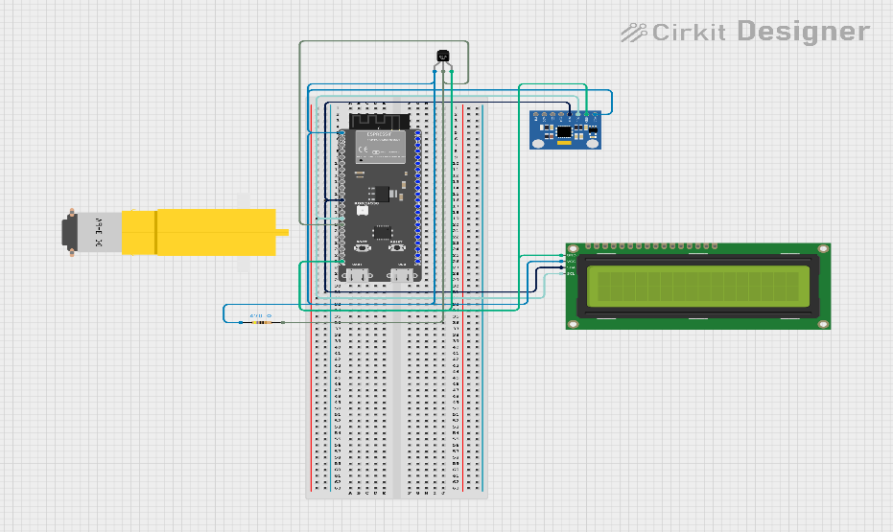
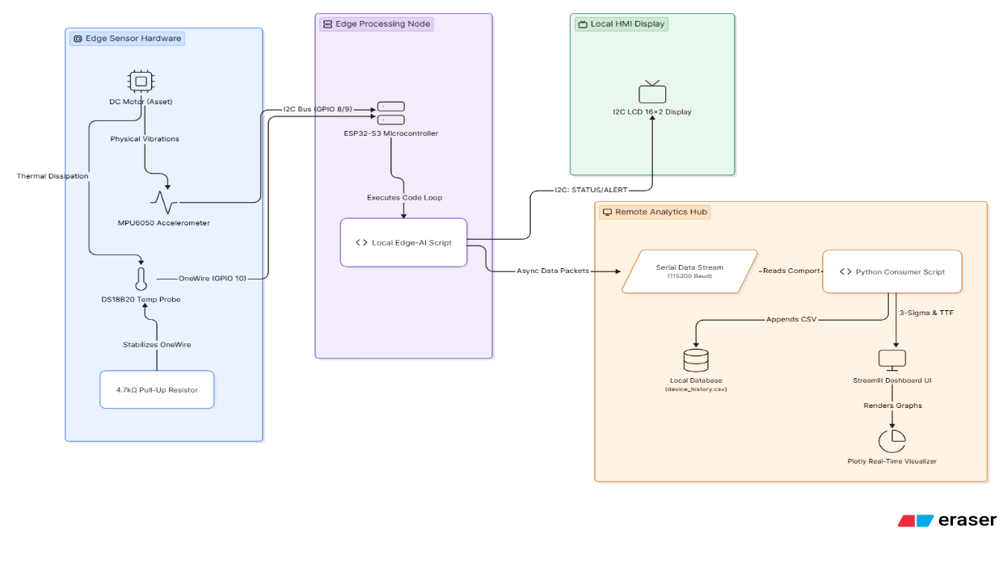
Result and Analysis
The developed IoT-Based Edge-AI Real-Time Fault Detection and Predictive Maintenance System was successfully implemented and tested under various operating conditions. The system continuously monitored vibration and temperature parameters of the DC motor and accurately identified abnormal conditions in real time.
During normal operation, the vibration magnitude remained within the safe range of approximately 1.7 m/s² to 2.5 m/s², while the temperature varied between 25°C and 30°C. Under these conditions, the LCD display continuously indicated a healthy system status, confirming stable machine operation.
To evaluate fault detection capabilities, different fault scenarios were simulated by introducing excessive vibration and thermal stress. When vibration levels exceeded 4.5 m/s², the system immediately generated a "HIGH VIBE LEVEL" alert. Similarly, when temperature readings crossed 38°C, the system displayed an "OVERHEATING ERROR" warning. In both cases, the Edge-AI fault detection logic successfully identified abnormal operating conditions and notified the operator without noticeable delay.
The telemetry data generated by the ESP32-S3 was successfully transmitted through serial communication and recorded for further analysis. Historical sensor data showed clear trends in machine behaviour, enabling the identification of performance degradation patterns. The collected dataset can serve as a foundation for future predictive maintenance models and remaining useful life estimation.
System Performance Analysis
Parameter | Healthy State | Fault State
Temperature | 25°C – 30°C | > 38°C
Vibration Magnitude | 1.7 – 2.5 m/s² | > 4.5 m/s²
System Status | SAFE | FAULT DETECTED
Response Time | Real-Time | Real-Time
Analysis
• The system successfully detected abnormal vibration and temperature conditions.
• Sensor fusion improved vibration monitoring by converting multi-axis acceleration data into a single vibration magnitude value.
• Real-time processing on the ESP32-S3 enabled immediate fault detection without requiring cloud connectivity.
• Local LCD alerts improved operator awareness and response time.
• Historical telemetry data provided valuable insights into machine health trends.
• The overall architecture demonstrated the feasibility of using Edge-AI and IoT technologies for predictive maintenance applications.
Key Observations
• Vibration levels increased significantly during simulated mechanical stress conditions.
• Temperature rise was observed during prolonged motor operation and overload scenarios.
• Fault conditions were detected accurately using predefined threshold values.
• The system maintained stable sensor communication throughout testing.
• The collected telemetry data can be further utilized for machine learning-based fault prediction and remaining useful life (RUL) estimation.
Overall Result
The project successfully achieved its objective of developing a real-time industrial asset monitoring and fault detection system. The integration of IoT sensors, Edge-AI processing, and predictive maintenance analytics demonstrated a reliable and scalable approach for improving equipment reliability and reducing unexpected downtime in industrial environments.

Learning Outcome
This internship project provided valuable hands-on experience in the fields of Embedded Systems, Industrial IoT, Edge Computing, and Predictive Maintenance. It helped bridge the gap between theoretical concepts learned in academics and their practical implementation in real-world industrial applications.
Through this project, I gained a strong understanding of hardware interfacing and sensor integration using the ESP32-S3 microcontroller. I learned how to establish communication between multiple devices using protocols such as I2C, OneWire, and Serial UART. Working with the MPU6050 vibration sensor and DS18B20 temperature sensor enhanced my knowledge of data acquisition and real-time monitoring systems.
The project also improved my programming skills in Arduino C++ and Python. I learned how to process sensor data, implement fault detection logic, and develop real-time monitoring applications. The implementation of vibration magnitude calculation using sensor fusion techniques provided practical exposure to signal processing concepts and machine condition monitoring.
In addition, I gained experience in data logging, analysis, and visualization using Python libraries such as Pandas, NumPy, and Matplotlib. This helped me understand how operational data can be transformed into meaningful insights for predictive maintenance and industrial decision-making.
The internship further enhanced my problem-solving, debugging, and system integration skills by requiring the successful coordination of hardware components, embedded software, and analytics tools. Overall, this project strengthened my understanding of Industry 4.0 technologies and provided practical experience in developing intelligent monitoring systems for industrial applications.

Conclusion
The IoT-Based Edge-AI Real-Time Fault Detection and Predictive Maintenance System for Industrial Assets successfully demonstrates the application of modern Industry 4.0 technologies for intelligent machine health monitoring. The project integrates vibration and temperature sensing with edge-level processing to continuously monitor the condition of industrial equipment and identify abnormal operating conditions in real time.
By utilizing an ESP32-S3 microcontroller, MPU6050 vibration sensor, and DS18B20 temperature sensor, the system effectively collects and processes operational data. The implementation of sensor fusion techniques and threshold-based fault detection enables rapid identification of excessive vibration and overheating conditions. The local LCD interface provides immediate alerts to operators, improving response time and reducing the risk of equipment damage.
The project also establishes a structured telemetry pipeline that supports historical data analysis and future predictive maintenance applications. The collected data can be used for trend analysis, anomaly detection, machine learning-based fault prediction, and remaining useful life estimation. This demonstrates the potential of combining IoT, Edge Computing, and Data Analytics to improve equipment reliability and maintenance efficiency.
Overall, the project achieved its objectives of real-time monitoring, fault detection, and predictive maintenance support. It provides a scalable and cost-effective foundation for smart industrial monitoring systems and highlights the importance of intelligent maintenance strategies in reducing downtime, improving operational efficiency, and supporting the transition toward Industry 4.0 and smart manufacturing environments.

References
Books
• Raj Kamal, Internet of Things: Architecture and Design Principles, McGraw Hill Education.
• Simon Monk, Programming Arduino: Getting Started with Sketches, McGraw Hill.
• Charles Platt, Make: Electronics, Maker Media.
• Steven F. Barrett, Embedded Systems: Design and Applications with the ARM Cortex-M Microcontrollers, Pearson.
• S. Sumathi and S. Esakkirajan, Fundamentals of Relational Database Management Systems, Springer.
Online Resources
• Arduino Official Documentation – https://www.arduino.cc
• ESP32-S3 Technical Documentation – https://docs.espressif.com
• MPU6050 Sensor Datasheet and Documentation
• DS18B20 Temperature Sensor Datasheet
• Python Official Documentation – https://docs.python.org
• Pandas Documentation – https://pandas.pydata.org
• NumPy Documentation – https://numpy.org
• Matplotlib Documentation – https://matplotlib.org
• Random Nerd Tutorials – ESP32 and IoT Development Guides
• Industry 4.0 and Predictive Maintenance Research Articles
Software Tools
• Arduino IDE
• Python 3.x
• Jupyter Notebook
• Pandas
• NumPy
• Matplotlib
• Serial Monitor
• ESP32 Board Package
• Git & GitHub
• Microsoft Excel
Assistance and Learning Support
• ChatGPT (OpenAI) – Guidance for project planning, documentation, report writing, and technical explanations.
• Gemini (Google) – Concept clarification and reference assistance.
• YouTube Educational Channels:
- Paul McWhorter (ESP32 & Arduino)
- Random Nerd Tutorials
- DroneBot Workshop
- GreatScott!
- freeCodeCamp
- IEEE Educational Content
• Research Papers and Technical Articles related to Industrial IoT, Edge AI, Condition Monitoring, and Predictive Maintenance.

Appendix

